**Install Smokeping-2.8.2 in Ubuntu 20.04**

**Ubuntu Server Network Configuration:**

root@ubuntu:~# vim /etc/netplan/00-installer-config.yaml

# This is the network config written by 'subiquity'

network:

ethernets:

ens160:

addresses:

- 10.200.1.222/30

gateway4: 10.200.1.221

nameservers:

addresses:

- 113.21.228.1 **/DNS**

search:

- triangle.com.bd

version: 2

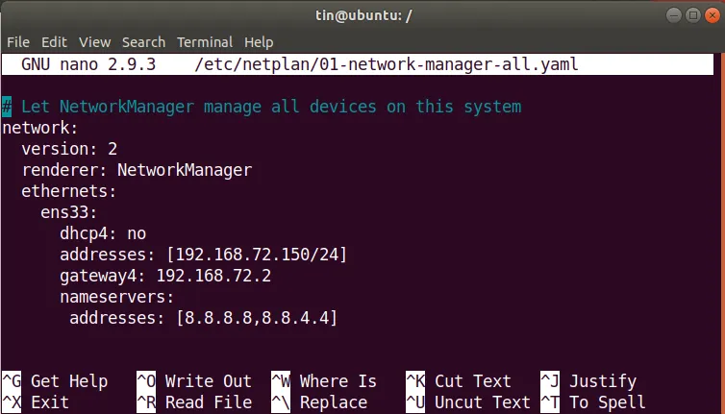

root@ubuntu:~# netplan apply

root@ubuntu:~# netplan --debug apply

root@ubuntu:~# sudo apt update && sudo apt upgrade –y

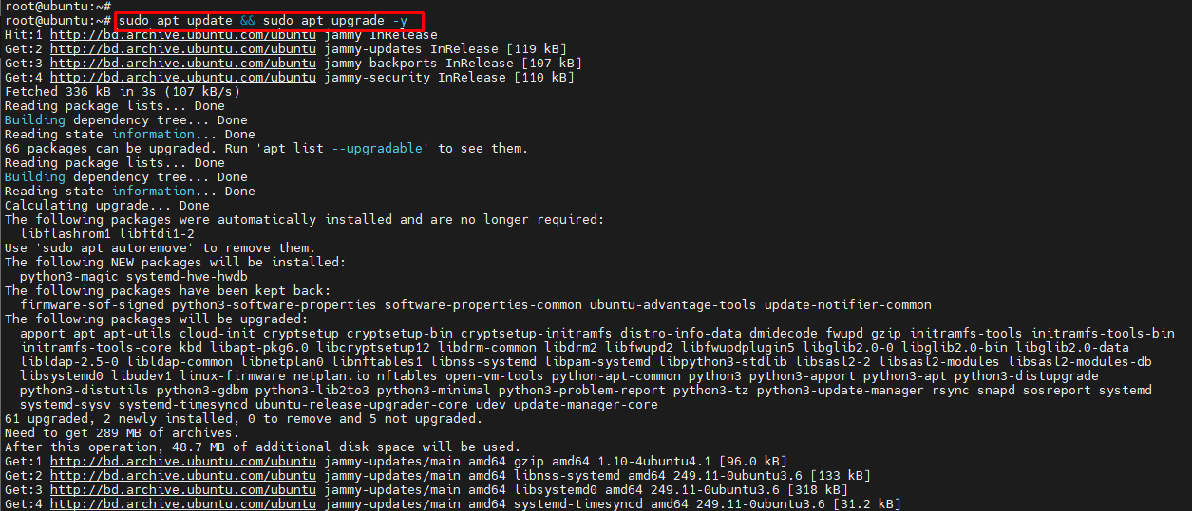

**SmokPing Server Config**

root@ubuntu:~# apt-get install --no-install-recommends gcc make libwww-perl libcgi-fast-perl libtext-soundex-perl libio-pty-perl libcrypt-ssleay-perl rrdtool librrds-perl libssl-dev libc6-dev wget autoconf fping acl curl apache2 git graphviz imagemagick libapache2-mod-fcgid mtr-tiny nmap rrdtool -y

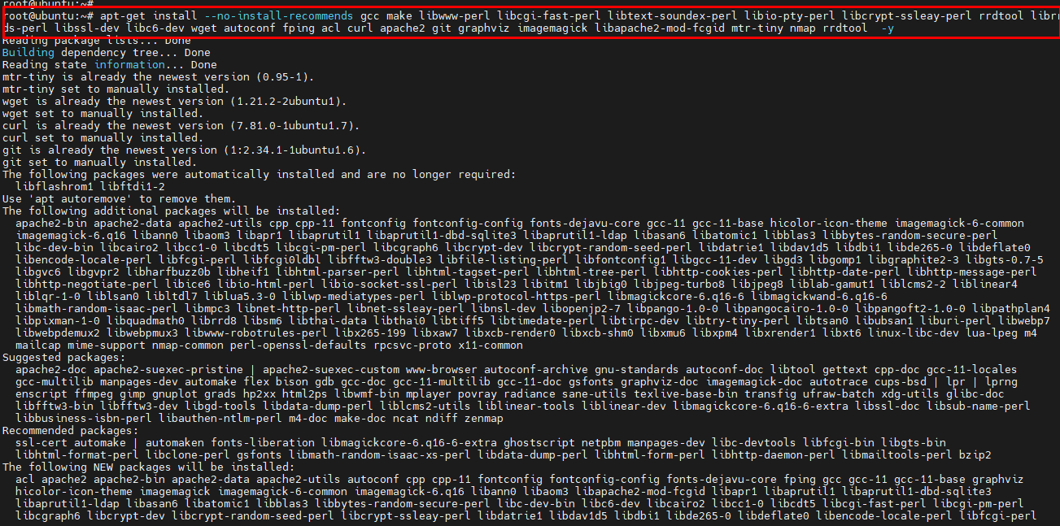

root@ubuntu:~# wget <https://oss.oetiker.ch/smokeping/pub/smokeping-2.8.2.tar.gz>

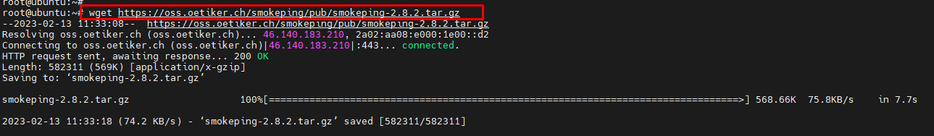

root@ubuntu:~# tar zxf smokeping-2.8.2.tar.gz

root@ubuntu:~# cd smokeping-2.8.2

root@ubuntu:~/smokeping-2.8.2# LC_ALL=C ./configure --prefix=/usr/local/smokeping

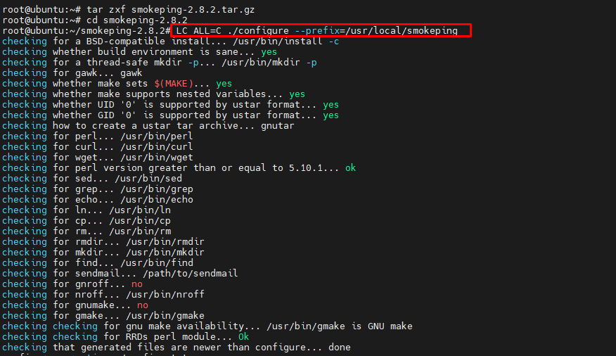

root@ubuntu:~/smokeping-2.8.2# sudo make install

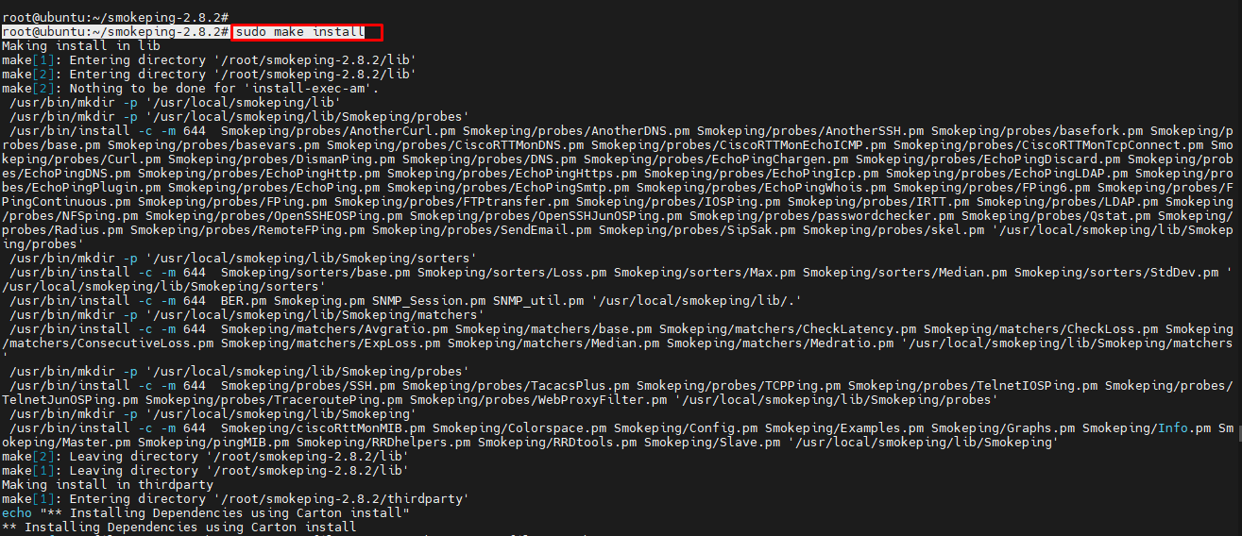

root@ubuntu:~/smokeping-2.8.2# /usr/local/smokeping/bin/smokeping -version

root@ubuntu:~/smokeping-2.8.2# mkdir -p /usr/local/smokeping/{cache,data,var}

root@ubuntu:~/smokeping-2.8.2# cd /usr/local/smokeping/

root@ubuntu:/usr/local/smokeping# ls



root@ubuntu:/usr/local/smokeping# vim /usr/local/smokeping/etc/config

*** General ***

owner = ITBrothers

contact = itbrothers24@gmail.com

mailhost = my.mail.host

imgcache = /usr/local/smokeping/cache

imgurl = cache

datadir = /usr/local/smokeping/data

piddir = /usr/local/smokeping/var

cgiurl = http://some.url/smokeping.cgi

smokemail = /usr/local/smokeping/etc/smokemail.dist

tmail = /usr/local/smokeping/etc/tmail.dist

syslogfacility = smokeping

*** Alerts ***

to = alertee@address.somewhere

from = smokealert@company.xy

+someloss

type = loss

pattern = >0%,*12*,>0%,*12*,>0%

comment = loss 3 times in a row

*** Database ***

step = 300

pings = 20

AVERAGE 0.5 1 1008

AVERAGE 0.5 12 4320

MIN 0.5 12 4320

MAX 0.5 12 4320

AVERAGE 0.5 144 720

MAX 0.5 144 720

MIN 0.5 144 720

*** Presentation ***

template = /usr/local/smokeping/etc/basepage.html.dist

charset = utf-8

+ charts

menu = Charts

title = The most interesting destinations

++ stddev

sorter = StdDev(entries=>4)

title = Top Standard Deviation

menu = Std Deviation

format = Standard Deviation %f

++ max

sorter = Max(entries=>5)

title = Top Max Roundtrip Time

menu = by Max

format = Max Roundtrip Time %f seconds

++ loss

sorter = Loss(entries=>5)

title = Top Packet Loss

menu = Loss

format = Packets Lost %f

++ median

sorter = Median(entries=>5)

title = Top Median Roundtrip Time

menu = by Median

format = Median RTT %f seconds

+ overview

width = 600

height = 50

range = 10h

+ detail

width = 600

height = 200

unison_tolerance = 2

"Last 3 Hours" 3h

"Last 30 Hours" 30h

"Last 10 Days" 10d

"Last 360 Days" 360d

*** Probes ***

+ FPing

binary = /usr/bin/fping

*** Targets ***

probe = FPing

menu = Top

title = Network Latency Grapher

remark = Welcome to the SmokePing ITBrothers

+ SearchEngine

menu = Search-Engine

title = Search Engine

++ Google-DNS

menu = Google-DNS

title = Google-DNS

host = 8.8.8.8

++ Google

menu = Google

title = google.com

host = google.com

++ Youtube

menu = Youtube

title = Youtube.com

host = youtube.com

root@ubuntu:/usr/local/smokeping# sudo /usr/local/smokeping/bin/smokeping --debug

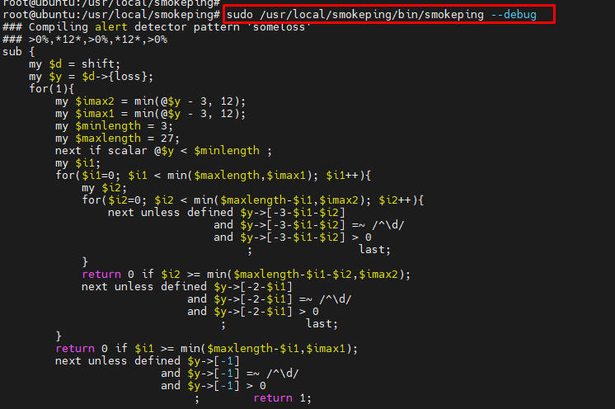

root@ubuntu:/usr/local/smokeping# vim /etc/systemd/system/smokeping.service

------------------------------------------------------------------------------------------

Add following config

[Unit]

Description=Smokeping Server

After=network.target

[Service]

Type=simple

ExecStart=/usr/local/smokeping/bin/smokeping --nodaemon /usr/local/smokeping/etc/config --logfile=/var/log/smokeping.log

[Install]

WantedBy=multi-user.target

------------------------------------------------------------------------------------------

root@ubuntu:/usr/local/smokeping# sudo systemctl enable smokeping

root@ubuntu:/usr/local/smokeping# sudo systemctl start smokeping

root@ubuntu:/usr/local/smokeping# systemctl status smokeping

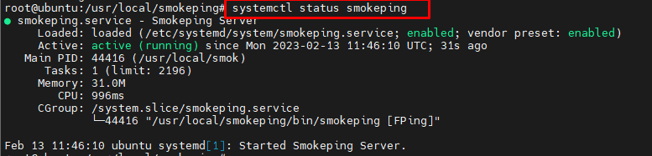

root@ubuntu:~# sudo chown www-data:www-data -R /usr/local/smokeping

root@ubuntu:~# vim /etc/apache2/conf-available/smokeping.conf

++++++++++++++++++++++++++++++++++++++++++++++++++++++++++

Alias /smokeping/cache /usr/local/smokeping/cache

Alias /smokeping /usr/local/smokeping/htdocs/

<Directory "/usr/local/smokeping/cache">

AllowOverride all

Require all granted

</Directory>

<Directory "/usr/local/smokeping/htdocs/">

Options FollowSymLinks ExecCGI

AllowOverride all

Require all granted

</Directory>

*****************************************************

root@ubuntu:~# sudo a2enconf smokeping

root@ubuntu:~# sudo a2enmod cgi

root@ubuntu:~# sudo systemctl restart apache2

root@ubuntu:~# sudo /usr/local/smokeping/bin/smokeping --debug

<http://SERVER-IP/smokeping/smokeping.fcgi.dist>

usermod -s /bin/bash noc ///User Permission

**============= Time Zone Set =============**

root@ubuntu:~# sudo timedatectl set-timezone Asia/Dhaka

root@ubuntu:~#

root@ubuntu:~# timedatectl

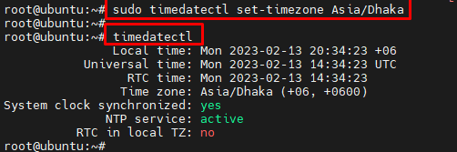

usermod -s /bin/bash tsladmin //User Root Login